Semester 1 Examination Revision
Multiple Choice Questions

Before answering each question, indicate which topic the question relates to and then select the correct answer.
___________________________________________________________________________

1. The stimulus-response-feedback model consists of the following components

I Receptor
II Effector
III Modulator
IV Stimulus
V Response

The correct order for this model is

(a) IV, V, III, I, II
(b) IV, I, III, II, V
(c) I, III, II, IV, V
(d) IV, I, II, III, V

2. Which of the following is an example of positive feedback?

(a) The lymphatic system defending the body against disease
(b) The lowering of a high body temperature
(c) The process of blood clotting
(d) The increase of osmotic pressure when body fluid levels are high

3. Two hormones are produced in the hypothalamus. Which option identifies the correct two hormones?

(a) anti-diuretic hormone and prolactin
(b) luteinising hormone and oxytocin
(c) luteinising hormone and prolactin
(d) anti-diuretic hormone and oxytocin

4. Water intoxication is associated with

- extremely low water concentration in blood plasma
- decreased secretion of ADH
- extremely low ion concentration in blood plasma
- overconsumption of sports drinks

5. Antibiotics would be least effective at combatting

(a) an infection cause by a rusty nail puncturing skin.
(b) E coli causing food poisoning.
(c) chlamydia caused by Chlamydia trachomatis.
(d) rhinovirus causing ear, nose and throat infection.

Questions 6 and 7 refer to the diagram below.

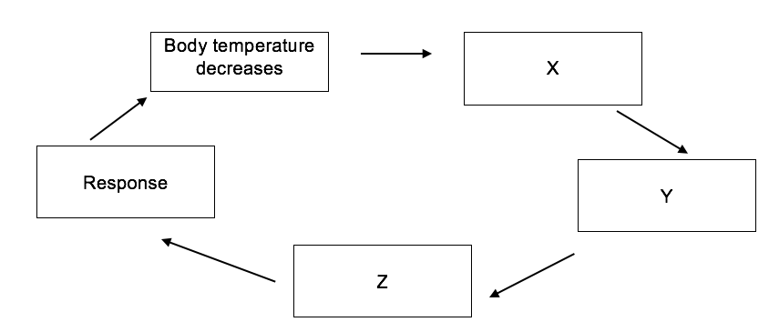

6. The diagram above represents a simple homeostatic feedback loop. The box labelled X represents a

(a) chemoreceptor.
(b) thermoreceptor.
(c) osmoreceptor.
(d) nociceptor.

7. Which of the following would be an appropriate behavioural response for this feedback loop?

(a) shivering
(b) increased metabolic rate
(c) reduction in sweating
(d) increase voluntary activity

8. Placing an ice pack on your head to cool down is an example of

(a) convection.
(b) conduction.
(c) radiation.
(d) evaporation.

9. Which of the following describes the transmission of a disease by a vector?

(a) chicken pox being spread around a primary school class
(b) the spread of HIV in drug addicts via shared needles
(c) malaria being spread by mosquitoes
(d) the development of an infection cause by a splinter

Questions 10 & 11 refer to the diagram below.

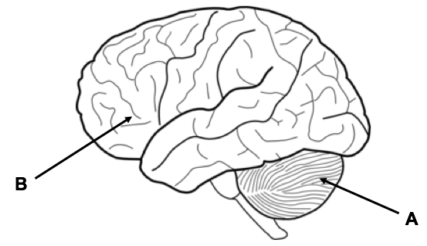

10. In the diagram above, the structure labelled A does not control

(a) fine motor skills.
(b) balance.
(c) personality.
(d) coordination.

11. Damage to structure B would affect

(a) behaviour.
(b) breathing.
(c) vision.
(d) metabolism.

12. In a myelinated neuron, the myelin sheath is formed by

(a) Schwann cells.
(b) nodes of Ranvier.
(c) dendrites.
(d) grey matter.

Questions 13 & 14 refer to the diagram below.

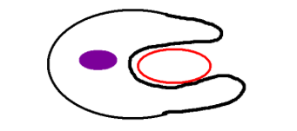

13. The diagram above illustrates the process of

(a) peristalsis.
(b) phagocytosis.
(c) pinocytosis.
(d) protein synthesis.

14. Which type of cell is represented in the above diagram?

(a) T-lymphocyte
(b) macrophage
(c) B-Lymphocyte
(d) memory cell

15. Breathing rate and temperature regulation are controlled by the:

(a) hypothalamus and the thermoregulatory centre respectively.
(b) nerves which exit the spinal cord near the neck.
(c) central chemoreceptors in the main blood vessels.
(d) medulla and hypothalamus respectively.

16. What effect will a decrease in anti-diuretic hormone have on the volume and concentration of urine produced?

(a) increased volume of dilute urine
(b) increased volume of concentrated urine
(c) decreased volume of dilute urine
(d) decreased volume of concentrated urine

Questions 17-19 refer to the diagram below.

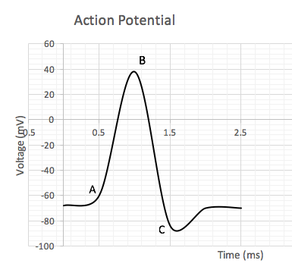

17. The point labelled A on the graph represents

(a) the refractory period.
(b) threshold.
(c) repolarisation.
(d) hyperpolarisation.

18. Which of the following best describes what is taking place between points B & C on the graph?

(a) sodium channels open causing sodium to diffuse into the cell
(b) sodium channels open causing sodium to diffuse out of the cell
(c) potassium channels open causing potassium to diffuse into the cell
(d) potassium channels open causing potassium to diffuse out of the cell

19. The size of the action potential

(a) stays the same regardless of stimulus.
(b) increases with a greater stimulus.
(c) is dependent on the strength of the stimulus.
(d) decrease with a lesser stimulus.

Questions 20 & 21 refer to the diagram below.

Y
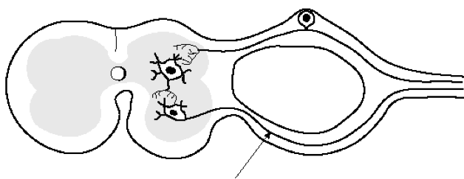

X

20. Which of the following correctly identifies the function of structure X in the diagram above?

(a) carry sensory impulses into the CNS from the effector
(b) carry sensory impulses out of the CNS toward the receptor
(c) carry motor impulses into the CNS from the receptor
(d) carry motor impulses out of the CNS toward the effector

21. The swelling at the point labelled Y illustrates the

(a) dorsal root ganglion.
(b) ventral root ganglion.
(c) motor root ganglion.
(d) efferent root ganglion.

22. Both the nervous and endocrine systems are concerned with communication. Which of the following statements concerning the nervous system and the endocrine system is correct?

- the release of several important hormones is controlled by the nervous system.
- the control of the endocrine system is voluntary whereas the control of the nervous system is involuntary.
- the effect of a hormone is always more specific than that of a nerve impulse.
- only the autonomic nervous system is involved in the control of homeostatic functions

23. An effector is normally a

(a) muscle or a gland.
(b) nerve or a muscle.
(c) gland or a nerve.
(d) tendon or a gland.

24. Which of the following responses is NOT an appropriate steady state control (negative feedback) system's response to the stimulus stated?

- increased secretion of glucocorticoids in response to high blood sugar.
- reduced secretion of thyroxine in response to a prolonged fall in temperature.
- increased breathing rate in response to a rise in carbon dioxide in the blood.
- increased secretion of gonadotrophic hormone releasing factor in response to a fall in progesterone level.

25. A substance which is capable of initiating an immune response is

(a) a pathogen.
(b) an antibody.
(c) an antigen.
(d) a lipid.

26. The use of vaccinations has received a lot of media attention in the last few years. Parents can be quite cautious regarding the use of vaccines. One of the most common concerns is the testing of vaccines on live animals. This is best described as

(a) a social concern.
(b) a cultural concern.
(c) an economic concern.
(d) an ethical concern.

27. The band of nerve fibres that connects the two halves of the brain is referred to as the

(a) cerebral cortex.
(b) cerebellum.
(c) corpus callosum.
(d) cerebrum.

28. Follicle stimulating hormone is released by the

(a) posterior pituitary gland.
(b) hypothalamus.
(c) ovary.
(d) anterior pituitary gland.

29. The diagram below shows a neuron found in the peripheral nervous system.

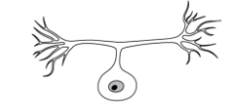

The correct structural classification of this neuron is

- sensory neuron
- bipolar neuron
- pseudounipolar neuron
- motor neuron

30. The human body is defended against viral infection by

(a) T-lymphocytes which engulf viruses.
(b) macrophage producing antibodies in response to the virus.
(c) B-lymphocytes producing antibodies in response to the virus.
(d) monocytes acting as phagocytes which produce antibodies.

- The endocrine gland that is correctly matched to the hormone it releases and its function
is:

  - Anterior pituitary lobe, oxytocin, contraction of uterus.
  - Thymus, thymosins, maturation of B-lymphocytes.
  - Pineal, melatonin, regulates sleep patterns.
  - Thyroid, Thyroid stimulating hormone, regulates metabolism.

- Which of the following is a homeostatic response?

  - The release of oxytocin, which contracts the uterus, to push the foetus towards the cervix.
  - The body fighting an infection with a fever.
  - Thrombocytes releasing chemicals to cause blood clotting.
  - Walking into a shady area in an attempt to cool down.

The next two questions refer to the diagram below.

Stimulus: Rising body temperature
A

B
D

C

- The diagram above represents a feedback cycle. In general terms, B and C refer to the

  - modulator and effector.
  - receptor and response.
  - receptor and effector.
  - modulator and response.

- An appropriate modulator in this cycle would be

  - Medulla oblongata
  - Hypothalamus
  - Pituitary gland
  - Thyroid gland

- The difference between white and grey matter within the brain is:

- The white matter is on the outside away from the nerve tracts, whilst the grey matter is on the inside.
- The grey matter contains the unmyelinated nerve fibres and the white matter contains the cell bodies.
- The white matter contains the dendrites of neurons, the grey matter contains the nerve fibres.
- The grey matter contains the cell bodies of neurons and the white matter contains the myelinated nerve fibres.

- The structure just above the point where the spinal cord enters the skull and is responsible
for regulating autonomic responses would be the

  - hypothalamus.
  - cerebrum.
  - cerebellum.
  - medulla oblongata.

- The part of the human brain that regulates hunger, thirst and sleeping patterns is the

  - hypothalamus.
  - cerebrum.
  - cerebellum.
  - medulla oblongata.

- The pituitary gland produces and secretes all of the following hormones except for

  - growth hormone.
  - thyroid stimulating hormone.
  - prolactin.
  - antidiuretic hormone.

- Choose the two correct words, to complete the following sentence.
The reabsorption of sodium ions and excretion of potassium ions is controlled by hormone __________ and secreted from the ___________.

  - cortisol, adrenal cortex
  - parathyroid hormone, parathyroids
  - aldosterone, adrenal cortex
  - cortisol, adrenal medulla

- An individual contracted malarial parasite after a mosquito took a blood meal from them. Which of the following methods would describe how this disease was transmitted?

  - By contact
  - By a vector
  - By body fluids
  - By ingestion

- Which of the following is not an example of a non-specific defence?
  - Sebum which contains substances that kill bacteria.
  - The beating motion of cilia within the respiratory system.
  - Cerumen produced by the gastric pits, killing most bacteria that are swallowed.
  - Urine is slightly acidic and provides a flushing action.

- Which of the following is true about passive immunity?

  - The patient’s immune system is stimulated to produce antibodies
  - The patient receives the antibodies for a specific pathogen, through an injection
  - This type of immunity is prolonged due to the development of memory cells
  - Only involves B lymphocytes, while the T lymphocytes are not stimulated.

- The following event and subsequent response that best describes what happens during anti-body mediated immunity, would be the

  - T lymphocyte presents the antigen to the B lymphocyte; the B lymphocyte produces clones and memory cells.
  - B lymphocyte is activated by an antibody; the B lymphocyte produces clones and memory cells.
  - B lymphocyte is activated by an antigen; the B cells can become either a plasma, suppressor or memory cell.
  - B lymphocyte is presented with an antigen; the B lymphocyte may become a clone that secretes specific antibodies.

- Herd immunity is most easily achieved by providing

  - natural passive immunity.
  - artificial active immunity.
  - artificial passive immunity.
  - natural active immunity.

- Which of the following is a property of a spinal reflex?

  - They occur under the conscious control of the cerebrum.
  - They are learnt through repetition.
  - They involve a small number of neurons.
  - They are regulated by positive feedback.

- Actinomycetes are bacteria that produce a substance that can penetrate a cell membrane
and disrupt protein synthesis, stopping the unicellular organism from reproducing. This
type of substance is referred to as an/a

  - antiviral drug
  - narrow-entry antibiotic
  - bactericidal antibiotic
  - bacteriostatic antibiotic

- Aerobic respiration is a chemical reaction that produces a number of waste products which are detected by different sensory receptor to maintain homeostasis. Those receptors that would be most sensitive to these wastes would be

  - osmoreceptors, chemoreceptors and alpha cells.
  - carotid and aortic bodies, osmoreceptors and central chemoreceptors.
  - thermoreceptors, osmoreceptors and beta cells.
  - peripheral and central chemoreceptors.

The next two questions refer to the diagram below

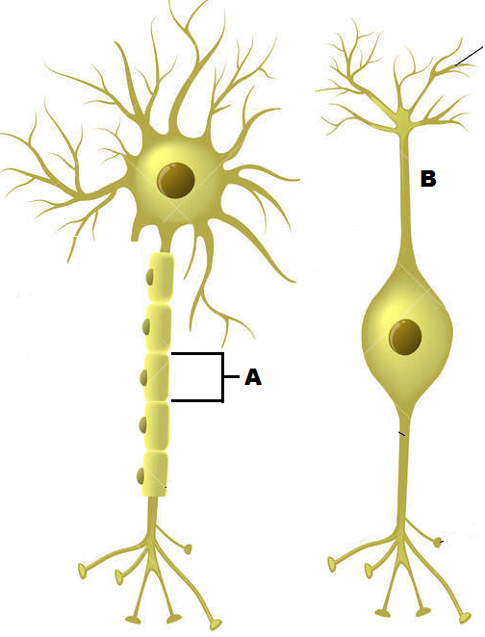

- The cell labelled A has the following function.

  - Forms the myelin sheath
  - Provides a conducting surface.
  - Secretes neurotransmitters.
  - Speeds up hormonal impulses.

- The cell labelled B is a:

  - Sensory multipolar neuron
  - Motor bipolar neuron
  - Unipolar interneuron
  - Sensory bipolar neuron

- The role of histamine is to:

- prevent clotting.
- make the walls of the blood capillaries more permeable.
- decrease the blood flow to the infected area.
- attract thrombocytes to the infected area.

- Increasing the carbon dioxide concentration in the blood will

  - increase the pH of the blood
  - incur hyperventilation
  - stimulate a nervous impulse through the vagus nerve
  - trigger a response from the chemoreceptors before a decrease in oxygen concentration.

- Glucagon will maintain blood glucose at homeostatic levels by

  - decreasing the production of glycogen
  - increasing the formation of glycogen
  - increasing the catabolism of glycogen
  - increasing the anabolism of glycogen

The following information relates to questions 53, 54 and 55.

A patient has complained of the following symptoms to their doctor:
- Feeling a lack of energy
- Unexplained weight loss
- Frequently craving foods with sugar

In response, the doctor had the patient’s blood glucose levels tested over
five consecutive days. The patient’s results, measured in millimoles per litre, can be seen in the
table below.

Day | 1 | 2 | 3 | 4 | 5
Glucose concentration (mmol/L) | 4.0 | 4.3 | 4.9 | 4.7 | 5.1

A normal range is between 4 and 6 mmol/L

- The mean glucose concentration in the patient’s bloodstream over the five days was

  - 4.6
  - 4.9
  - 4.8
  - 4.5

- The percentage change in the patient’s blood glucose level from the first day to the fifth
day was

  - 27.5% decrease
  - 21.5% increase
  - 27.5% increase
  - 21.5% increase

- Which of the following patient’s glands and their respective hormones may be underactive?

  - Beta cells of the pancreas; glucagon
  - Adrenal cortex; cortisol
  - Alpha cell of the pancreas; insulin
  - Thyroid gland; ACTH

- Complete the following sentence by choosing the correct sequence of words.
Once a hormone has produced the required effect, it needs to be broken down. This mostly occurs in the _______ and the ________. This process is known as ___________

  - target cells; liver; enzyme amplification
  - kidney; liver; negative feedback
  - target cells; kidney; hormone clearance
  - kidney; liver; hormone clearance

- Which one of the four substances would not be found in a traditional vaccine?

  - Attentuated micro-organisms
  - Virulent micro-organisms
  - Dead micro-organisms
  - Inactivated bacterial toxins

- Choose the best description of a virus

  - A protein coat surrounding either DNA or RNA
  - A protein coat with both RNA and DNA
  - A non-living entity that causes disease
  - An organism that invades and multiplies within bacteria

- Choose the best description of a bacteriophage

  - A virus that reproduces within bacteria
  - A bacterium that is resilient to viral infections
  - Bacteria that are injected with a virus to produce insulin
  - Bacterium that have a specific rod shape and flagella

- Choose the protective reflex that is correctly matched to its modulator and the nervous system that would stimulate it.

  - Sneezing; medulla oblongata; somatic division
  - Coughing; hypothalamus; autonomic division
  - Vomiting; medulla oblongata; autonomic division
  - Diarrhoea; medulla oblongata; autonomic division

- Which of the following hormones does not affect blood glucose levels?

(a) Thyroxine
(b) Cortisol
(c) Aldosterone
(d) Adrenaline

Questions 62 & 63 refer to the information below.

A reflex arc consists of the following components

I Motor neuron
II Sensory neuron
III Interneuron
IV Effector
V Stimulus

- Which of the components named above is part of the afferent division of the nervous system?

(a) I
(b) II
(c) III
(d) IV

- Place the components in the correct order

(a) II, V, III, I, IV
(b) V, I, IV, III, II
(c) IV, V, II, III, I
(d) V, II, III, I, IV

- The peripheral chemoreceptors are located in the

(a) carotid artery and aorta.
(b) hypothalamus.
(c) medulla oblongata.
(d) adrenal medulla.

- In cold temperatures, a person may curl up into a ball. This purpose of this action is to

(a) reduce the surface area, losing heat via radiation.
(b) reduce the surface area, decreasing heat loss via radiation.
(c) reduce the surface area, increasing the metabolic rate.
(d) reduce the surface area, decreasing the metabolic rate.

- Which of the following correctly identifies an effect of the parasympathetic division of the nervous system?

(a) Dilation of bronchioles
(b) Decreasing saliva production
(c) Increasing sweat production
(d) Constricting pupils of the eye

Questions 67 - 69 refer to the diagram below.

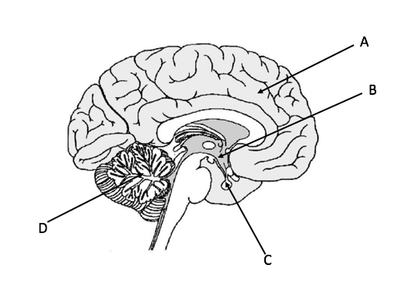

- Osmoreceptors are located in structure

(a) A
(b) B
(c) C
(d) D

- The main function of structure D is

(a) conscious thought.
(b) osmoregulation.
(c) balance and coordination.
(d) language.

- A person makes the voluntary decision to take a drink of water. The structure involved in this decision-making process is

(a) A
(b) B
(c) C
(d) D

- The element involved the release of neurotransmitters into the synaptic cleft is

(a) sodium
(b) potassium
(c) calcium
(d) iron

- Anti-diuretic hormone is produced in the

(a) anterior pituitary gland.
(b) posterior pituitary gland.
(c) hypothalamus.
(d) medulla oblongata.

- The function of the myelin sheath is to

(a) allow the nerve impulse to travel down the entire length of the neuron.
(b) allow the nerve impulse to cross the synapse.
(c) ensure the nerve impulse only travels in one direction.
(d) increase the speed at which a nerve impulse travels.

- Which of the following statements correctly describes an action of protein hormones?

(a) Pass directly across the cell membrane.
(b) Bind with a receptor inside the cell.
(c) Activates a secondary messenger within the cell.
(d) Binds with an enzyme on the cell membrane.

Questions 74 - 76 refer to the diagram below.

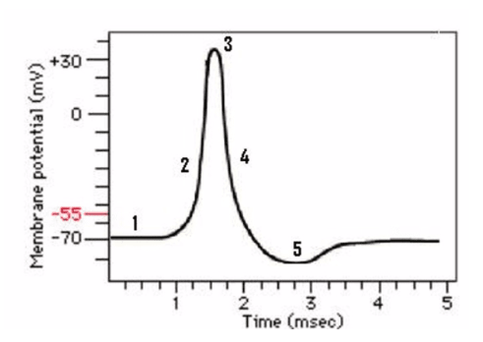
- At point 2 on the graph

(a) sodium ions are moving into the cell.
(b) sodium ions are moving out of the cell
(c) potassium ions are moving into the cell.
(d) potassium ions are moving out of the cell

- At which point on the graph is the neuron at rest?

(a) 1
(b) 3
(c) 4
(d) 5

- The point on the graph marked 55mV is referred to as

(a) hyperpolarisation.
(b) refractory period.
(c) repolarisation.
(d) threshold.

- A bacteriophage is

(a) a bacterium which requires a virus to reproduce.
(b) a bacterium which requires other bacteria to reproduce.
(c) a virus which requires a bacterium to reproduce.
(d) a virus which does not require a host to reproduce.

- While travelling on a crowded train, a person suffering with a cold sneezes in your direction without covering their mouth. This type of transmission of pathogen is referred to as

(a) transmission by vector.
(b) transmission by water droplets.
(c) airborne transmission.
(d) transmission by body fluids.

- Autoimmunity is best described as

(a) an automatic immune response.
(b) an immune response controlled by the autonomic nervous system.
(c) an immune response caused by the presence of ‘self’ antigens.
(d) an immune response against the body’s own healthy tissue.

- The posterior pituitary gland produces

(a) antidiuretic hormone.
(b) prolactin.
(c) oxytocin.
(d) none of the above.

- Damage to the corpus callosum would cause

(a) lack of coordination between the left and right hemispheres
(b) lack of balance, coordination and fine motor skills.
(c) an increase in the rate of contraction of respiratory muscles.
(d) an increase in the production of hormones.

- Which of the following correctly describes the function of mucus in the respiratory tract?

(a) Dissolve microorganisms
(b) Prevent microorganisms entering the stomach
(c) Trap any micro-organisms you breath in
(d) Move microorganisms upwards towards the throat

- The production of glucose from a non-carbohydrate source is referred to as

- glycolysis.
- glycogenesis.
- gluconeogenesis.
- glycogenolysis.
Questions 84 and 85 refer to the information below.

In a metabolism study, 15 human subjects were placed in an experimental chamber and the rate at which it used up oxygen was measured. The measurements were repeated for each subject at a range of chamber temperatures.

The average results are shown in the following graph.
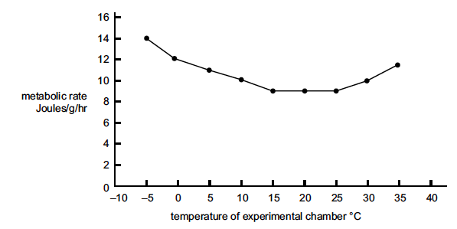

- The Independent variable in this experiment is the

(a) rate of oxygen consumption.
(b) temperature of the environment.
(c) temperature of the people.
(d) physiological and behavioural responses to hot and cold

- Which of the following would ensure that the experiment is accurate?

(a) using the same method to determine metabolic rate.
(b) repetition of the experiment with a new group.
(c) using a large sample size.
(d) recording observations about the people’s behaviour.

- A vaccine created by reducing the virulence of a pathogen is referred to as

(a) an attenuated vaccine.
(b) a toxoid vaccine.
(c) a sub-unit vaccine.
(d) a dead vaccine.

- Which row in the table below correctly identifies a hormone involved in controlling blood sugar and the structure that secretes it.

 | Hormone | Secreted by
(a) | Insulin | Alpha cells
(b) | Glycogen | Beta cells
(c) | Insulin | Liver
(d) | Glucagon | Pancreas

- Which of the following is not a function of antibodies?

(a) Dissolve pathogen
(b) Make soluble substances insoluble
(c) Produce cytokines
(d) Coat pathogens to stimulate cell removal

- Lysosyme is an enzyme found in tears. A function of lysozyme is to

(a) break down bacteria on the eye.
(b) trap bacteria on the eye.
(c) flush out bacteria from the eyes.
(d) lubricate surface of the eyes.

- A person with type 1 diabetes

(a) can produce insulin but cannot respond to it.
(b) cannot produce insulin but can respond to it.
(c) can produce insulin and can respond to it.
(d) cannot produce insulin and cannot respond to it.

Question 91 refers to the diagram below.

- Which of the following correctly identifies each of the missing components of the nervous system?

